
Agenda & practical information


Transnational Training Seminar

Pilsen, Czech Republic

29th – 30th November 2018

Smart City Polygon

Na Strilne 1929/8 Bolevec, Pilsen

Thursday, 29th November 2018
Time | Activity | Remarks
08:30-09:00 | Registration
9:00-10:30 | MODULE I Transnational Training Seminar: “The power of Geographic Information Systems (GIS) for managing dynamic street lighting data” (I part) | Anna Nowacka  Fabio Remondino
10:30-10:45 | Coffee break
10:45-12:15 | MODULE I Transnational Training Seminar: “The power of Geographic Information Systems (GIS) for managing dynamic street lighting data” (II part) | Anna Nowacka  Fabio Remondino
12:15-13:00 | Lunch break
13:00-15:00 | MODULE II Transnational Training Seminar: “Finding a suitable funding source and financing model for energy efficiency upgrade of street lighting infrastructure” (I part) | Aleksandra Novikova  Irina Starmo
15:00-15:15 | Coffee break
15:15-16:45 | Smart Polygon excursion
19:00 | Dinner (organized by PORSENNA), „Na spilce”
Friday, 30th November 2018
Time | Activity | Remarks
8:00-8:45 | Registration
8:45-10:30 | Module III - Info Event “Promoting the concrete implementation of dynamic lighting within the EU” | José Mercado  Bénédicte Martin
10:30-10:45 | Coffee Break
10:45-11:45 | Module III - Info Event “Promoting the concrete implementation of dynamic lighting within the EU” | José Mercado  Bénédicte Martin
11:45-12:30 | Lunch break
12:30-14:15 | Module IV - Transnational Training Seminar : Public lighting standards | Prof. Axel Stockmar, LCI Light Consult International
14:15-14:30 | Coffee Break
14:30-19:30 | Excursion to the Town of Sušice (transport secured)

Practical information’s
MEETING PLACE
Smart City Polygon, Na Strilne 1929/8 Bolevec, Pilsen

GETTING TO (BY CAR)

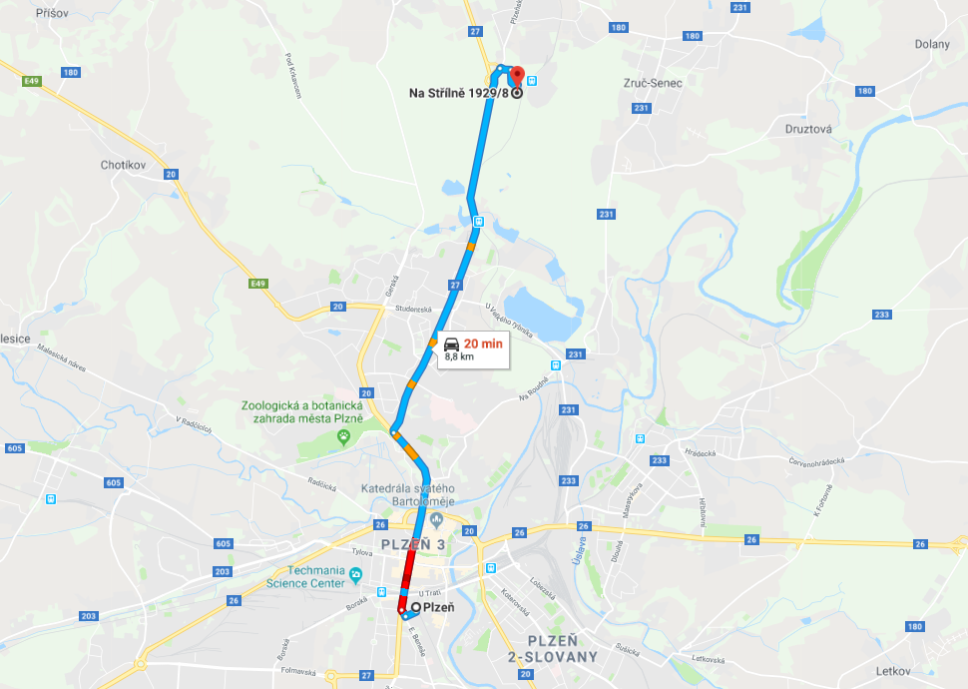

ACCOMODATION
- Hotel Panorama (V Lomech 11, Plzeň, 323 00, Czech Republic)
- Hotel Central (Náměstí Republiky 358/33, Plzeň, 32200, Czech Republic)
- Hotel U Pramenu (Na Roudné 123, Plzeň, 30100, Czech Republic)

For any questions, please contact:
Vítězslav Malý
PORSENNA o.p.s.
Mobile: + 39 0547 356215
E-mail: maly@porsenna.cz

